CHALLENGE-9

1. Create a customized Docker image using a Dockerfile.

PURPOSE: The purpose of creating a customized Docker image using a Dockerfile is to package an application along with all its dependencies, configurations, and required software into a single, portable image. This ensures that the application runs consistently across different environments, such as development, testing, and production.

OBJECTIVE:
- Learn how to write a Dockerfile to automate image creation.
- Create a custom Docker image based on an existing base image (e.g., Nginx, Ubuntu, or Tomcat).
- Add custom application files and configurations to the Docker image.
- Build the Docker image using the docker build command.
- Run a container from the custom image and verify its functionality.
- Understand key Dockerfile instructions such as FROM, COPY, RUN, WORKDIR, EXPOSE, and CMD.
- Gain hands-on experience in creating reusable, portable, and version-controlled Docker images.
- Simplify application deployment by packaging everything required into a single Docker image.
- Ensure consistency and reproducibility of application environments across different systems.

STEP BY STEP IMPLEMENTATION:

- create a new Dockerfile and in that we have to write the modules to create a image like nginx.
- After that we have to build that image by running the Dockerfile.

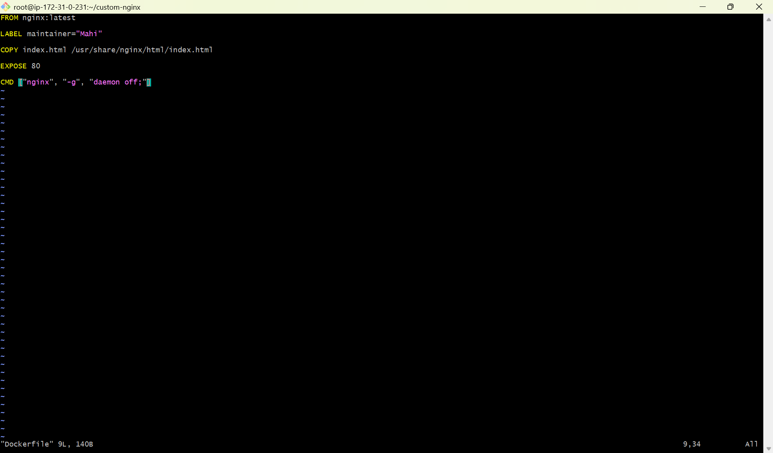

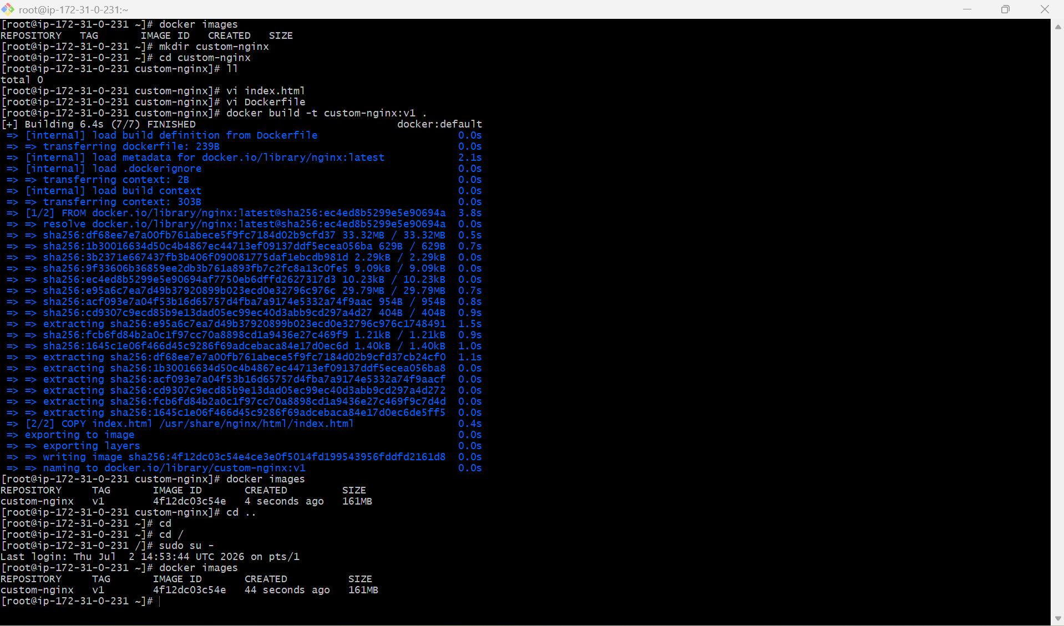

2. Push the image to Docker Hub.

PURPOSE: The purpose of pushing a Docker image to Docker Hub is to store the image in a centralized, cloud-based repository so it can be easily shared, versioned, and deployed across different environments. Docker Hub enables developers and teams to access the same image from anywhere, simplifying application distribution and deployment.

OBJECTIVE:

- Learn how to authenticate with Docker Hub using the docker login command.
- Tag a local Docker image with the correct Docker Hub repository name.
- Push the Docker image to a Docker Hub repository using the docker push command.
- Verify that the image has been successfully uploaded and is available on Docker Hub.
- Understand how Docker Hub serves as a central image registry for storing and sharing Docker images.
- Enable image reuse across development, testing, and production environments.
- Gain practical experience with Docker image versioning using tags (e.g., v1, latest).
- Facilitate collaboration by making Docker images accessible to team members and deployment pipelines.

STEP BY STEP IMPLEMENTATION:

- We have to create new image by using Dockerfile.
- After that create a new repo in the Docker hub.
- After that we have to login into the docker hub from the CLI by using the command -> docker login
- After that we have to change the name from the cutom image name to the repo name using command -> docker tag <oldimagename>:<tag> <dockerhubReponame>:tag>
- After that we have to push the image to the Docker hub.

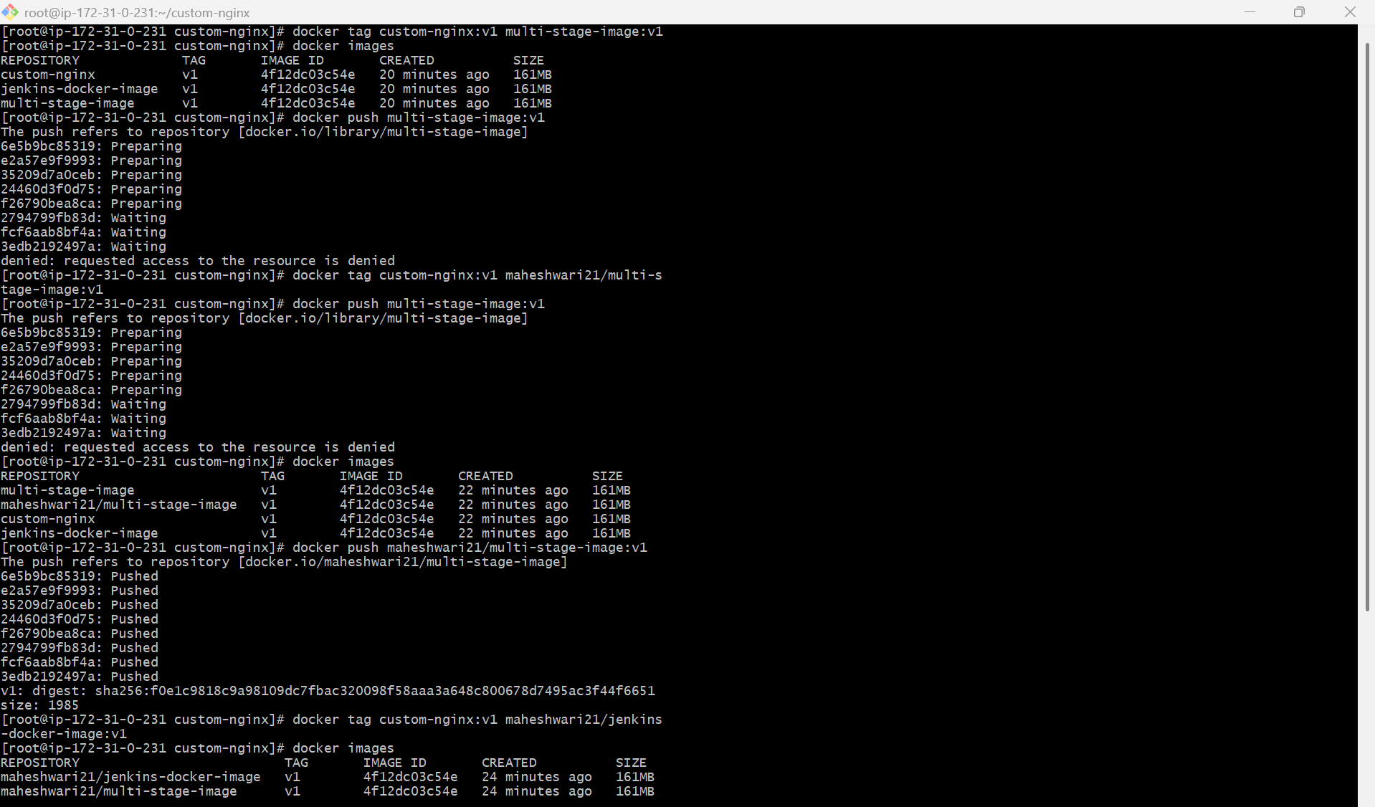

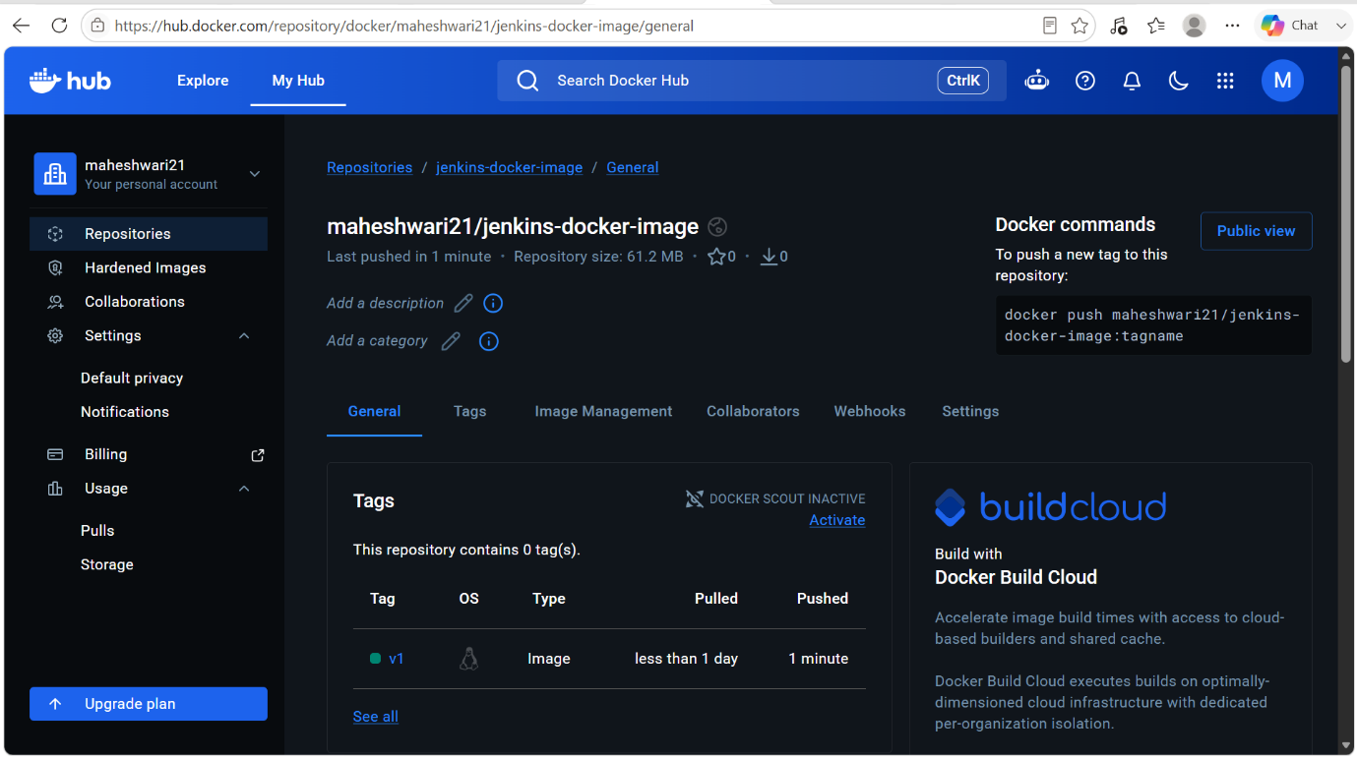

3. Push the same image to Amazon ECR.

PURPOSE: The purpose of pushing the same Docker image to Amazon Elastic Container Registry (Amazon ECR) is to securely store and manage container images in AWS. Amazon ECR integrates with AWS services such as Amazon ECS, Amazon EKS, and AWS Lambda, making it easier to deploy, manage, and scale containerized applications in the AWS cloud.

OBJECTIVE:

- Learn how to create an Amazon ECR repository.
- Authenticate Docker with Amazon ECR using the AWS CLI.
- Tag a local Docker image with the Amazon ECR repository URI.
- Push the Docker image to the Amazon ECR repository using the docker push command.
- Verify that the image has been successfully uploaded to Amazon ECR.
- Understand how Amazon ECR serves as a secure, private container image registry.
- Gain hands-on experience with managing Docker images in the AWS cloud.
- Enable seamless deployment of container images to AWS services such as Amazon ECS, Amazon EKS, and AWS Lambda.
- Understand Docker image tagging and versioning for efficient image management and deployment.

STEP BY STEP IMPLEMENTATION:

- Create a new repository in the AWS ECR service from the CLI.
aws ecr create-repository \
--repository-name jenkins-docker-image \
--image-scanning-configuration scanOnPush=true \
--region ap-southeast-2
- Then verify the configurations ->
aws ecr describe-repositories \
--repository-names jenkins-docker-image \
--region ap-southeast-2
- Login to AWS ECR ->
aws ecr get-login-password --region ap-southeast-2 | \
docker login \
--username AWS \
--password-stdin \
683620640096.dkr.ecr.ap-southeast-2.amazonaws.com
- Tag the docker image ->
docker tagcutom-nginx:v1 \
683620640096.dkr.ecr.ap-southeast-2.amazonaws.com/jenkins-docker-image:v1
- Then push the image to the AWS ECR ->
docker push \
683620640096.dkr.ecr.ap-southeast-2.amazonaws.com/jenkins-docker-image:v1
- Verify the results in the AWS ECR.

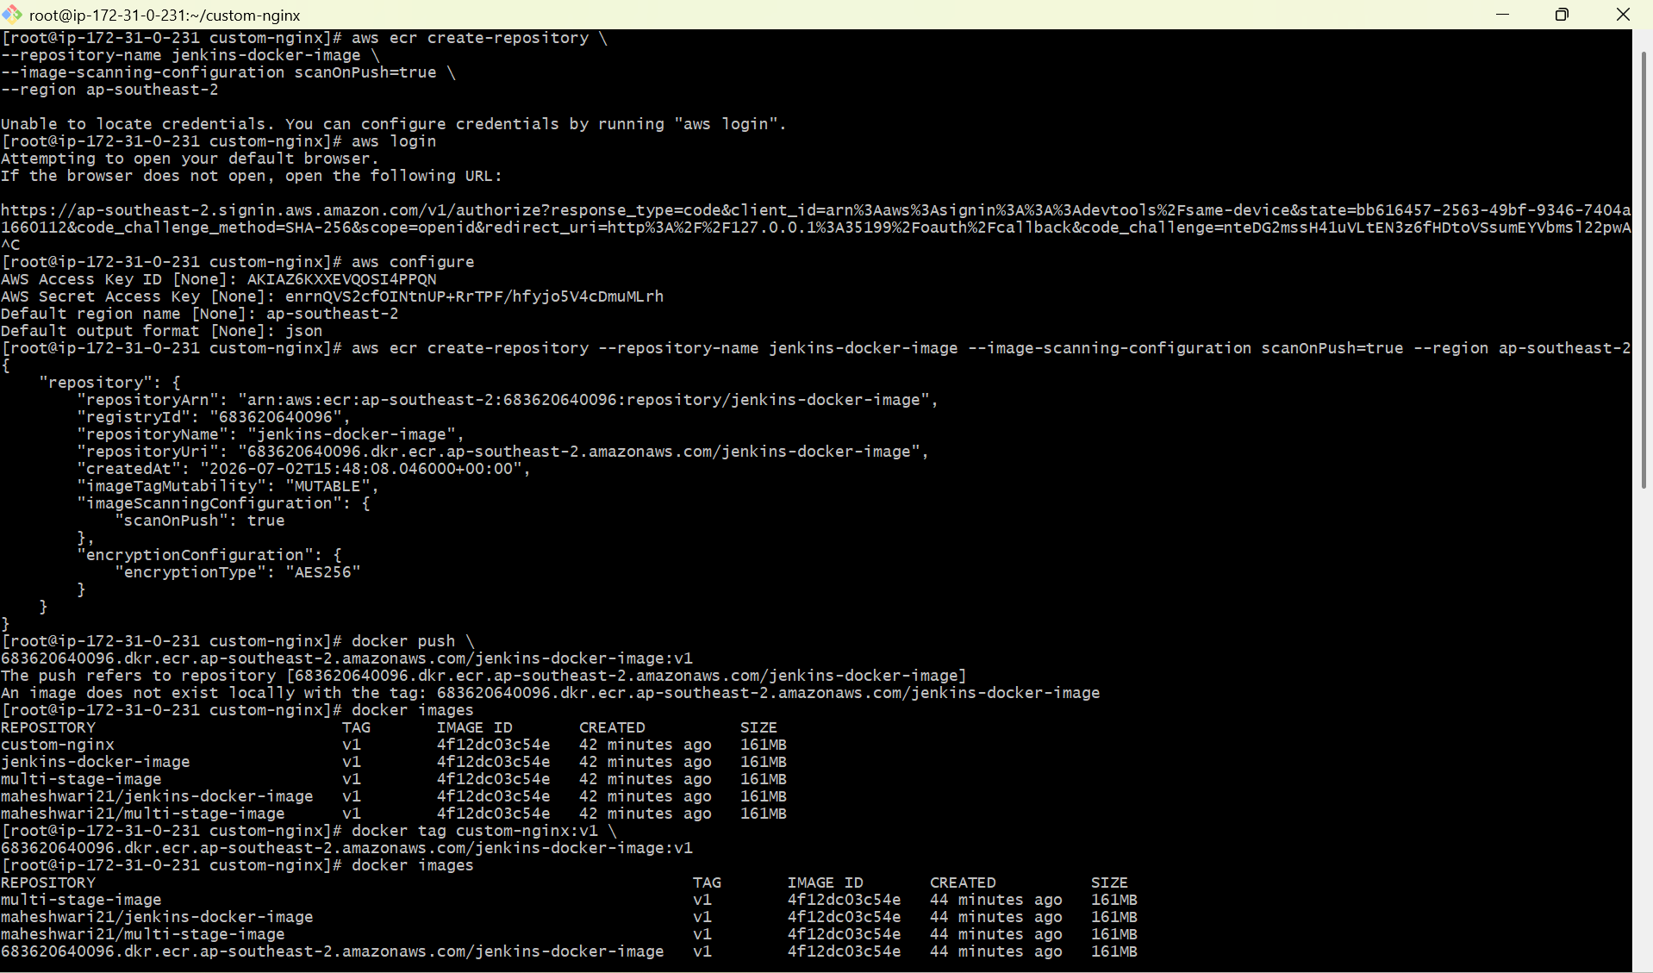

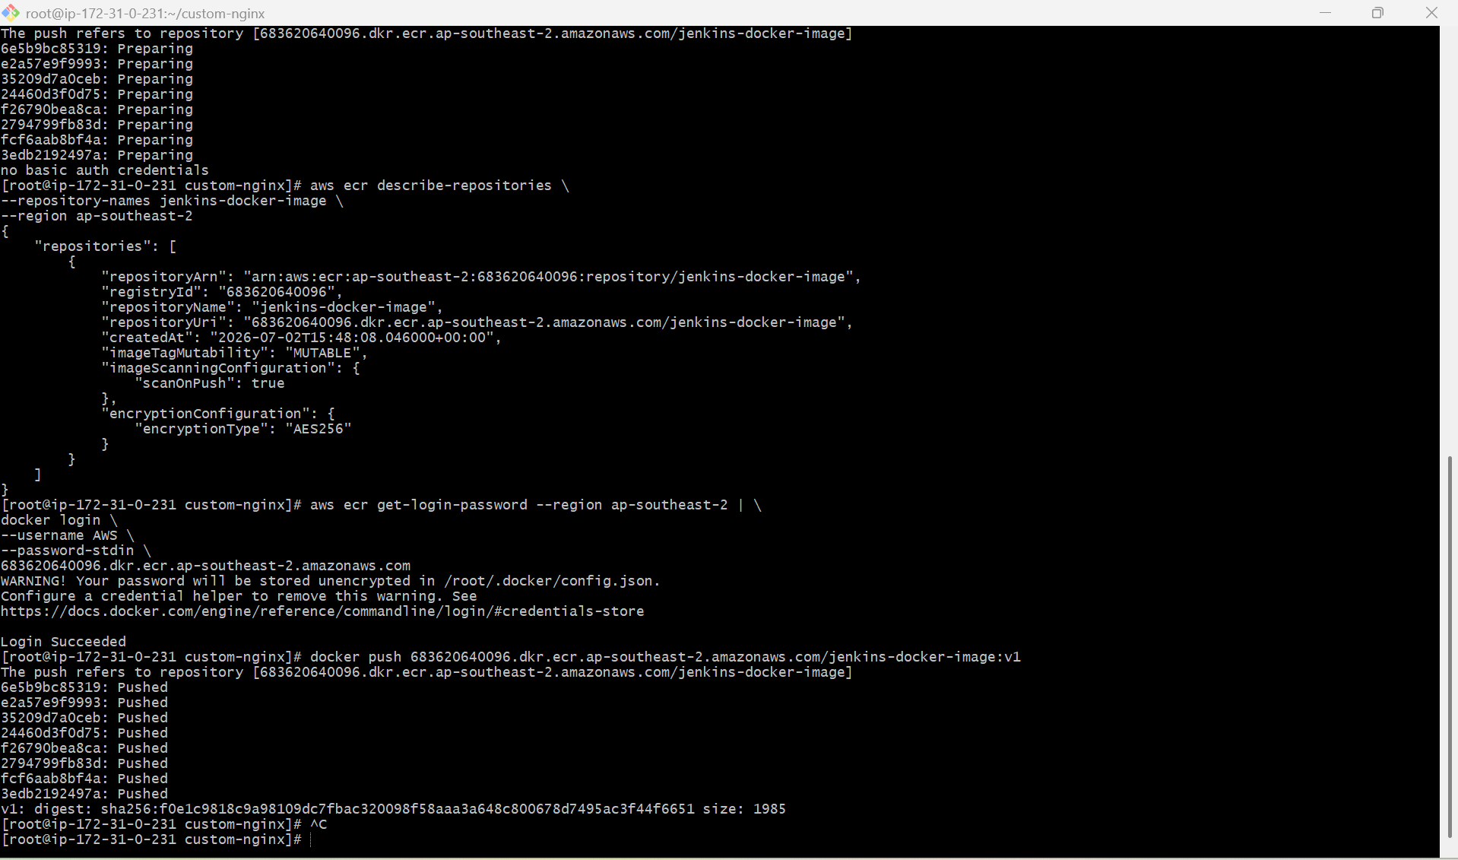

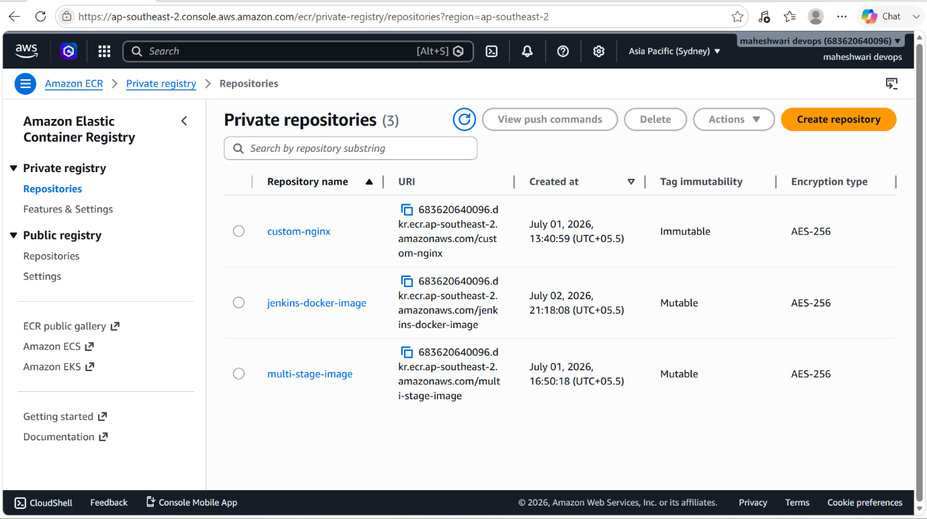

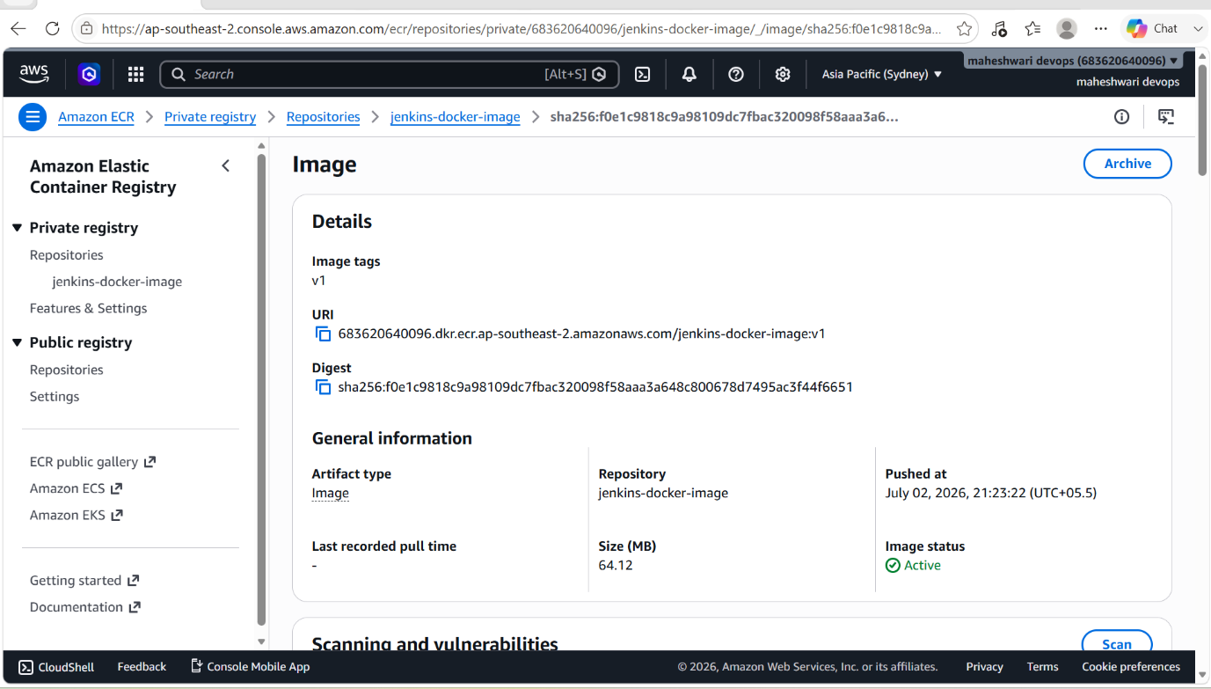

4. Provision one EC2 instance using Terraform and install Jenkins.

PURPOSE: The purpose of provisioning an Amazon EC2 instance using Terraform and installing Jenkins is to automate the creation of cloud infrastructure and set up a Continuous Integration/Continuous Delivery (CI/CD) server. This approach ensures infrastructure consistency, reduces manual effort, and enables faster, repeatable deployments.

OBJECTIVE:
- Learn Infrastructure as Code (IaC) concepts using Terraform.
- Provision an Amazon EC2 instance on AWS using Terraform configuration files.
- Configure AWS provider credentials and required Terraform resources.
- Automate the creation of networking, security groups, and compute resources.
- Install and configure Jenkins on the EC2 instance.
- Access the Jenkins web interface and complete the initial setup.
- Understand how Terraform automates infrastructure provisioning and management.
- Gain hands-on experience with integrating Terraform and Jenkins for DevOps workflows.
- Ensure infrastructure deployments are repeatable, scalable, and version-controlled.
- Build a foundation for implementing CI/CD pipelines on AWS using Jenkins.

STEP BY STEP IMPLEMENTATION:
- Create a directory terraform-jenkins.
- In that directory, we have to create file called main.tf for our terraform code.

CODE:

provider "aws" {
region = "ap-south-1"
}

resource "aws_security_group" "jenkins_sg" {
name = "jenkins-sg"

ingress {
from_port = 22
to_port = 22
protocol = "tcp"
cidr_blocks = ["0.0.0.0/0"]
}

ingress {
from_port = 8080
to_port = 8080
protocol = "tcp"
cidr_blocks = ["0.0.0.0/0"]
}

egress {
from_port = 0
to_port = 0
protocol = "-1"
cidr_blocks = ["0.0.0.0/0"]
}
}

resource "aws_instance" "jenkins" {
ami = "ami-0f58b397bc5c1f2e8" # Amazon Linux 2 (update for your region)
instance_type = "t2.micro"
key_name = "your-keypair-name"
vpc_security_group_ids = [aws_security_group.jenkins_sg.id]

user_data = <<-EOF
#!/bin/bash
yum update -y

# Install Java
amazon-linux-extras install java-openjdk11 -y

# Add Jenkins Repository
wget -O /etc/yum.repos.d/jenkins.repo https://pkg.jenkins.io/redhat-stable/jenkins.repo
rpm --import https://pkg.jenkins.io/redhat-stable/jenkins.io-2023.key

# Install Jenkins
yum install -y jenkins

# Start Jenkins
systemctl enable jenkins
systemctl start jenkins
EOF

tags = {
Name = "Terraform-Jenkins"
}
}

- After that verify terraform is installed or not.
- By the commands ->

  - Install terraform - sudo dnf install -y yum-utils
  - Add the hashicorp repo - sudo yum-config-manager --add-repo https://rpm.releases.hashicorp.com/AmazonLinux/hashicorp.repo
  - Install terraform - sudo dnf -y install terraform
  - Check terraform version – terraform --version

- Initialize the terraform -> terraform init
- After that validate the configuration -> terraform validate
- Preview the structure -> terraform plan
- Provision the instance -> terraform apply.
- Now we can see the new instance will be launched in AWS.

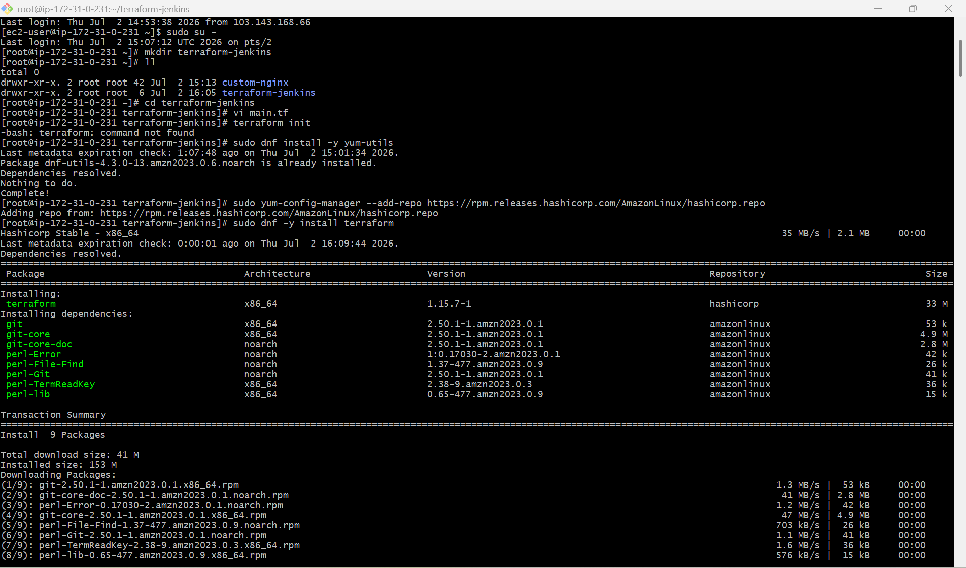

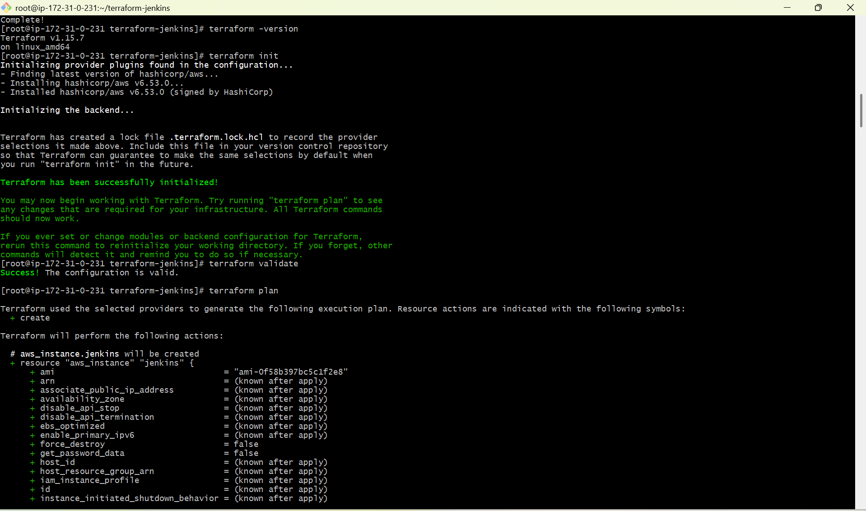

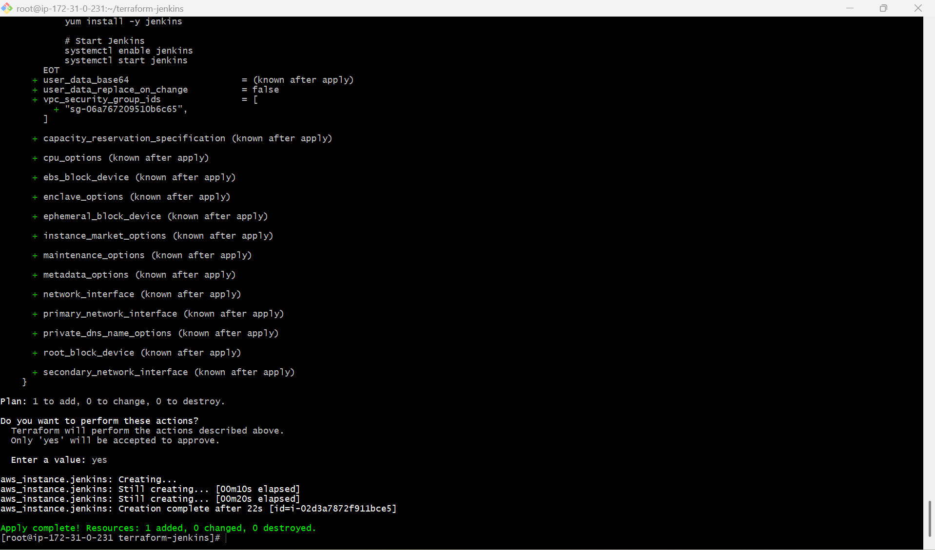

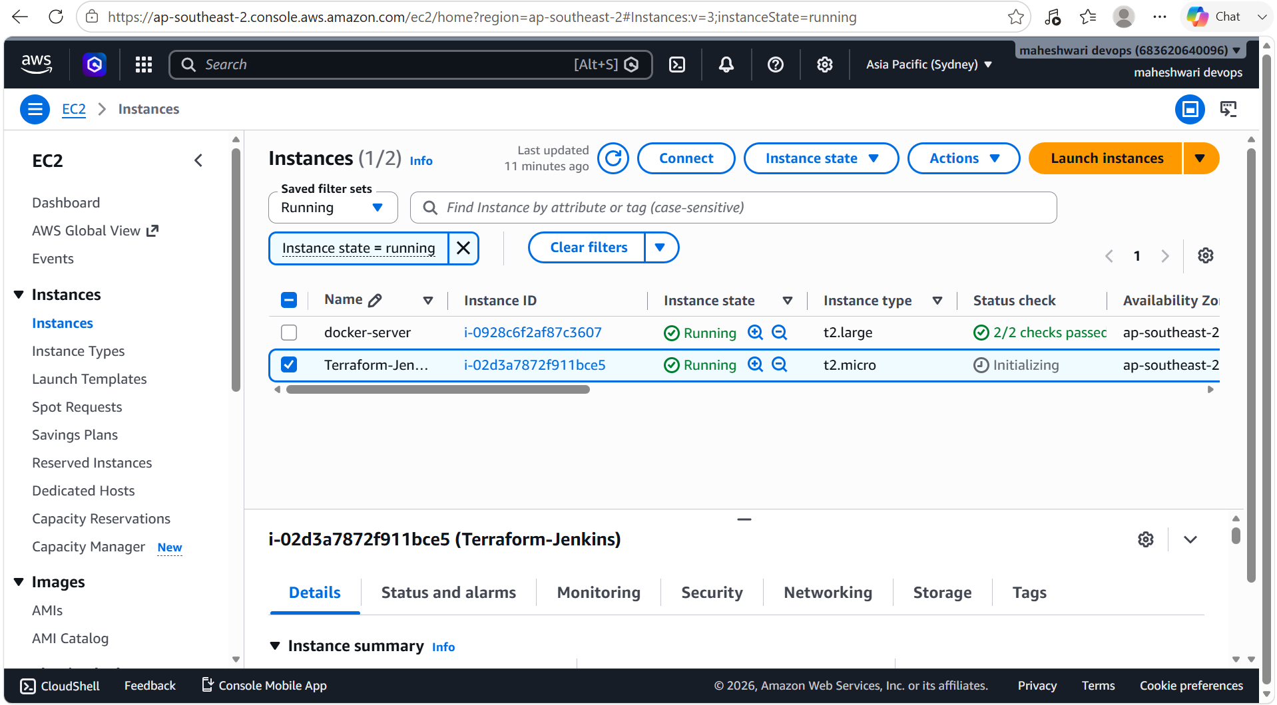

5. Create one Jenkins job to build and push the Docker image to Docker Hub.

Source:https://github.com/betawins/Python-app.git

PURPOSE: The purpose of this experiment is to automate the process of building a Docker image from a GitHub source repository and pushing it to Docker Hub using a Jenkins Pipeline. This demonstrates the use of Jenkins for Continuous Integration (CI) by integrating source code management, Docker image creation, and image publishing into a single automated workflow.

OBJECTIVE:

- Learn how to create a Jenkins Pipeline job.
- Integrate Jenkins with a GitHub repository.
- Clone the application source code from the GitHub repository (https://github.com/betawins/Python-app.git).
- Build a Docker image using the application's Dockerfile.
- Configure Docker Hub credentials securely in Jenkins.
- Authenticate Jenkins with Docker Hub.
- Push the Docker image to a Docker Hub repository automatically.
- Understand the role of Jenkins in automating Docker image build and deployment processes.
- Gain hands-on experience with Continuous Integration (CI) using Jenkins and Docker.
- Reduce manual effort and ensure consistent, repeatable Docker image builds and publishing.

STEP BY STEP IMPLEMENTATION:

- Create a image with the Dockerfile in the jenkins-docker directory.
- After that in the Docker file, we have to place the content in the docker file ->

FROM jenkins/jenkins:lts

USER root

RUN apt-get update && \
apt-get install -y docker.io && \
apt-get clean

USER jenkins
- Then build the image from the Docker file -> docker build -t jenkins-docker-image:v2
- After that make sure that the jenkins user can access the Docker socket in the jenkins-container -> docker exec -u root -it jenkins-container
- Then in the jenkins container -> docker ps -a
- After that the run the jenkins-image ->
docker run -d \
--name jenkins-container \
--user root \
-p 8080:8080 \
-p 50000:50000 \
-v jenkins_home:/var/jenkins_home \
-v /var/run/docker.sock:/var/run/docker.sock \
jenkins-docker-image:v2
- Then in the jenkins browser access with the publicIP:8080.
- Create a new job with the pipeline job style and write a pipeline
pipeline {
agent any

environment {
IMAGE_NAME = "YOUR_DOCKERHUB_USERNAME/python-app"
IMAGE_TAG = "v1"
}

stages {
stage('Clone Repository') {
steps {
git branch: 'main',
url: 'https://github.com/betawins/Python-app.git'
}
}

stage('Build Docker Image') {
steps {
sh 'docker build -t ${IMAGE_NAME}:${IMAGE_TAG} .'
}
}

stage('Docker Login') {
steps {
withCredentials([usernamePassword(
credentialsId: 'dockerhub-creds',
usernameVariable: 'DOCKER_USER',
passwordVariable: 'DOCKER_PASS'
)]) {
sh '''
echo $DOCKER_PASS | docker login -u $DOCKER_USER --password-stdin
'''
}
}
}

stage('Push Image') {
steps {
sh 'docker push ${IMAGE_NAME}:${IMAGE_TAG}'
}
}
}
}
- Then click on build now and the job will get success.

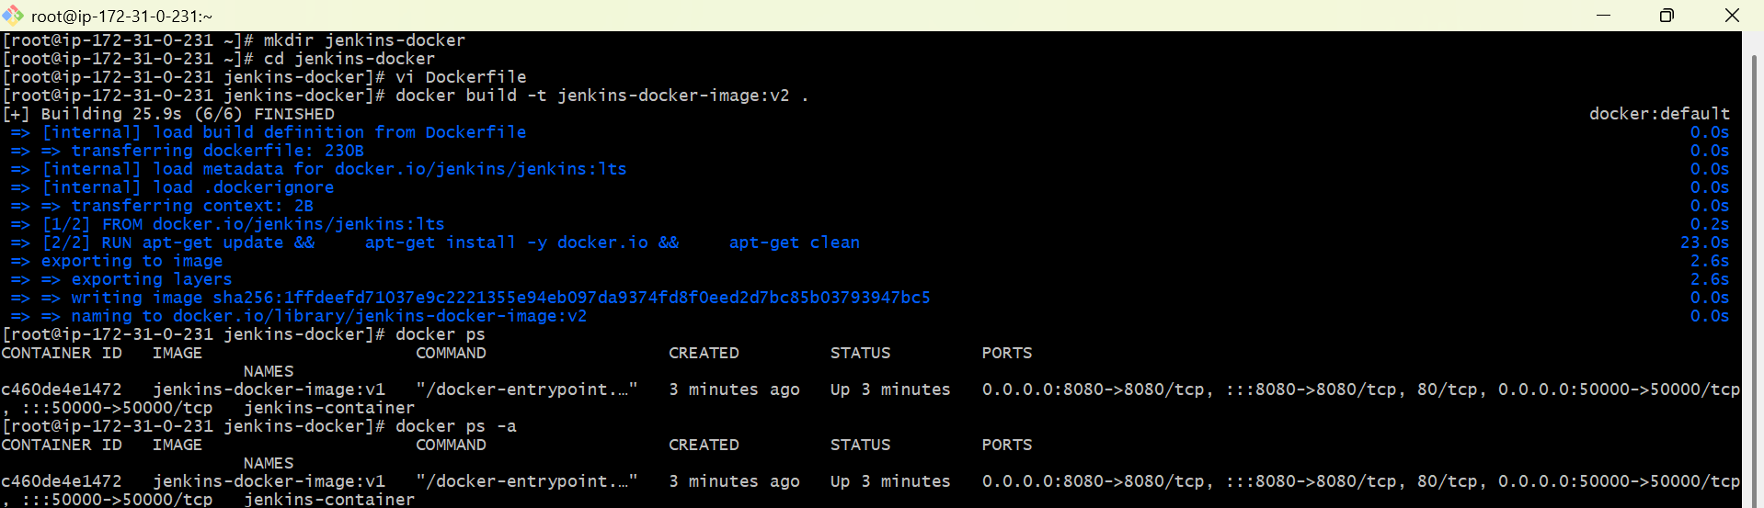

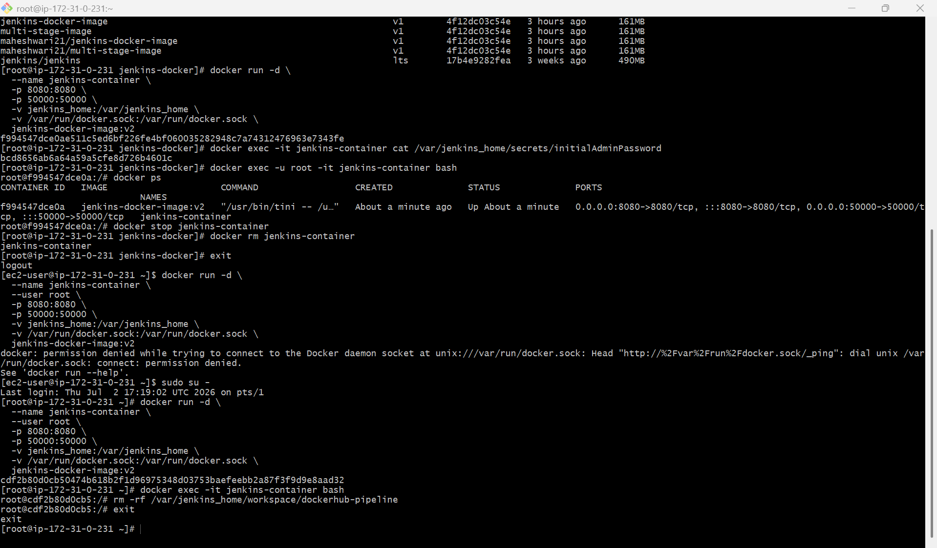

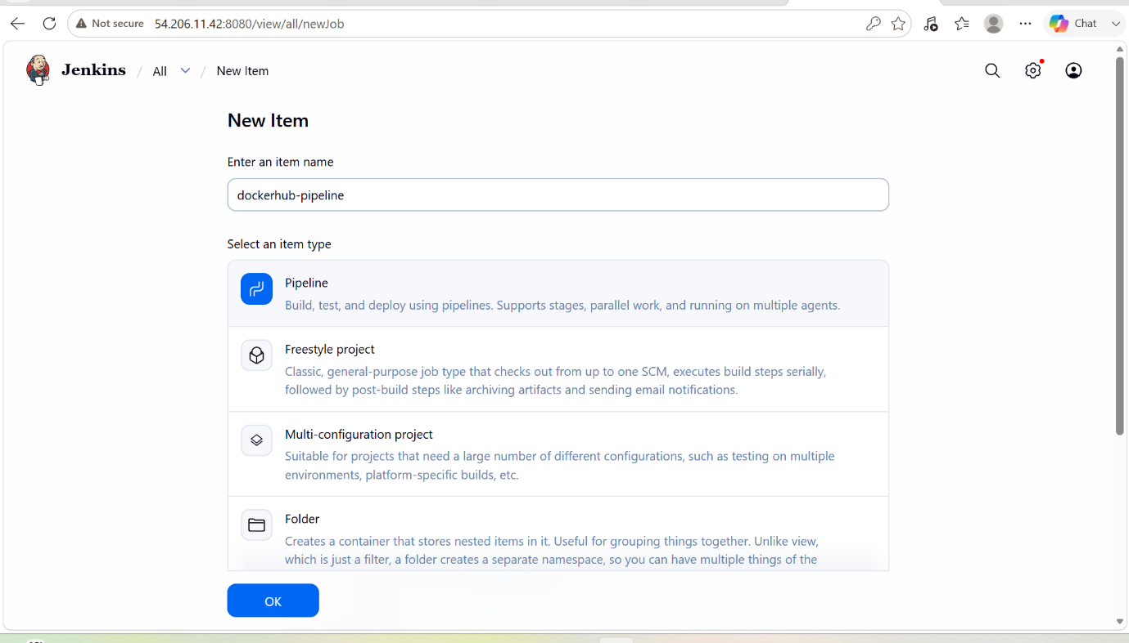

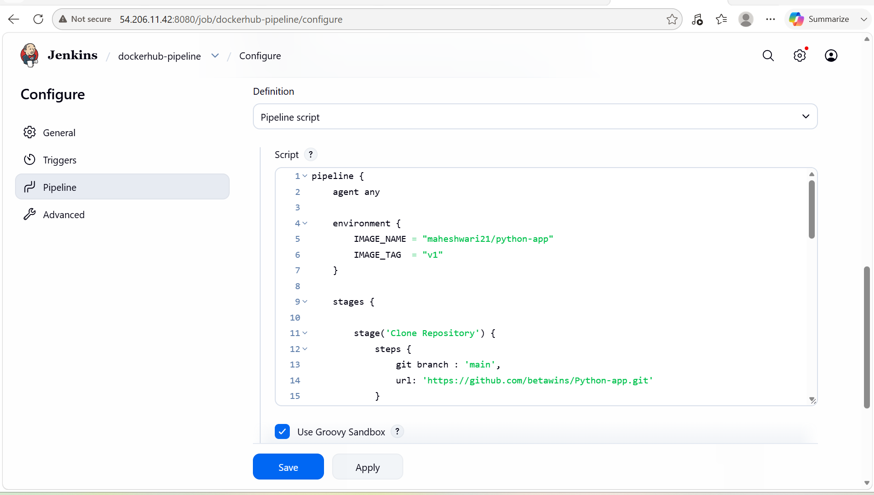

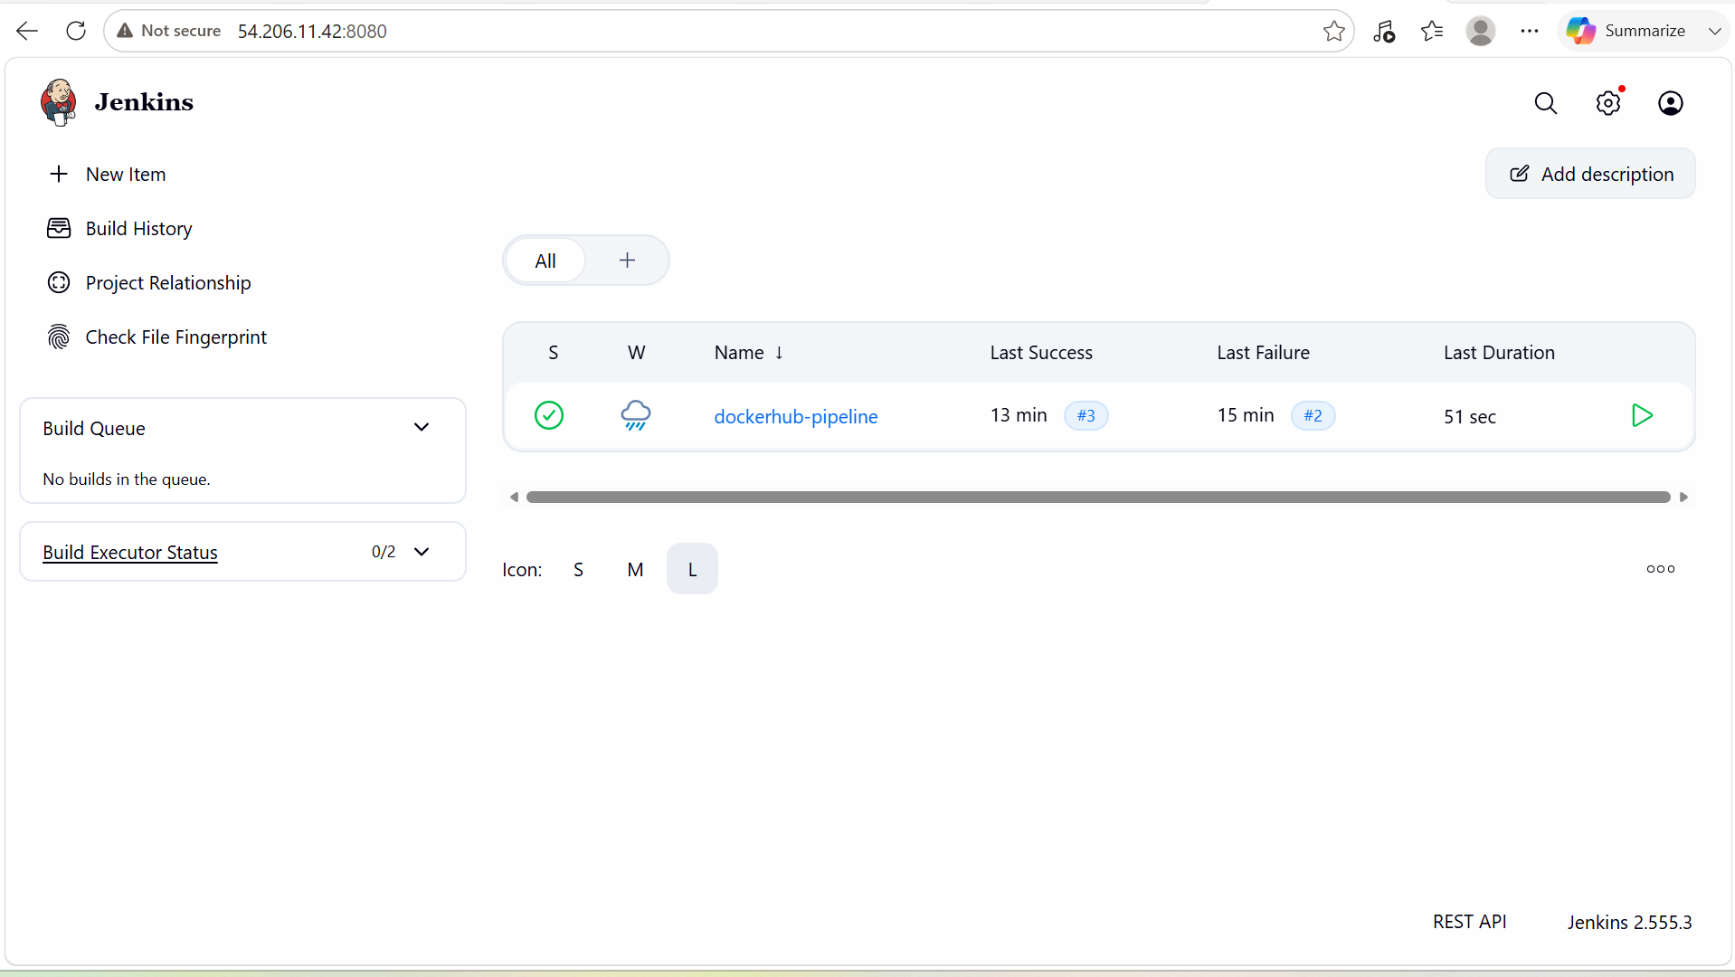

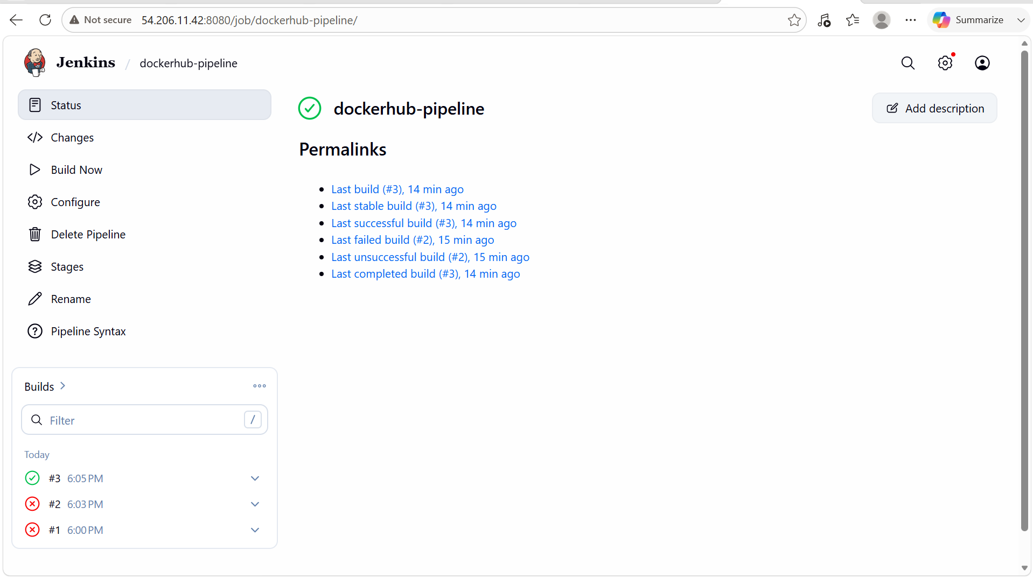

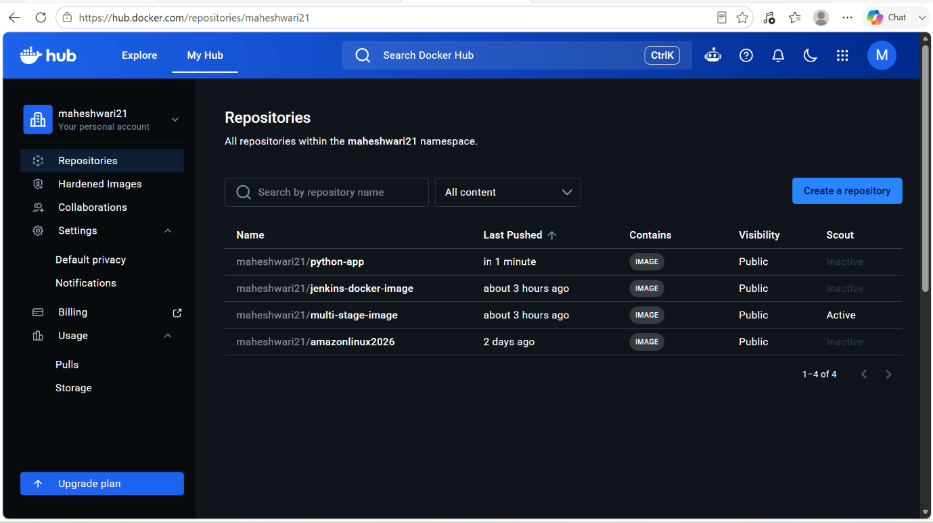

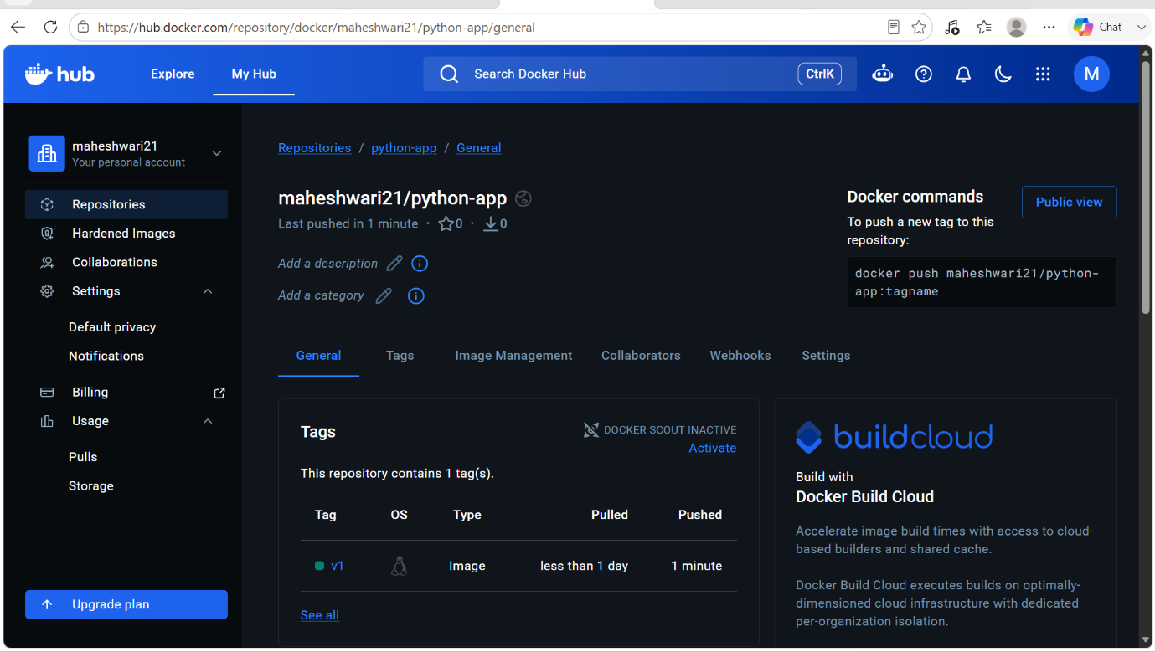

Source Codes: https://github.com/betawins/docker-tasks.git

1. From thefrontend source code, write a Dockerfile, build a Docker image, run it, and push that image to your Docker registry.

- First of all clone the repo from the github with the command -> git clone <https repo url>
- After that we have to get into that repo and into the frontend source repo.
- There we have to create Dockerfile as am using nginx as a base image.
- Then build a image from the Dockerfile.
- Then run the image on the port 80.

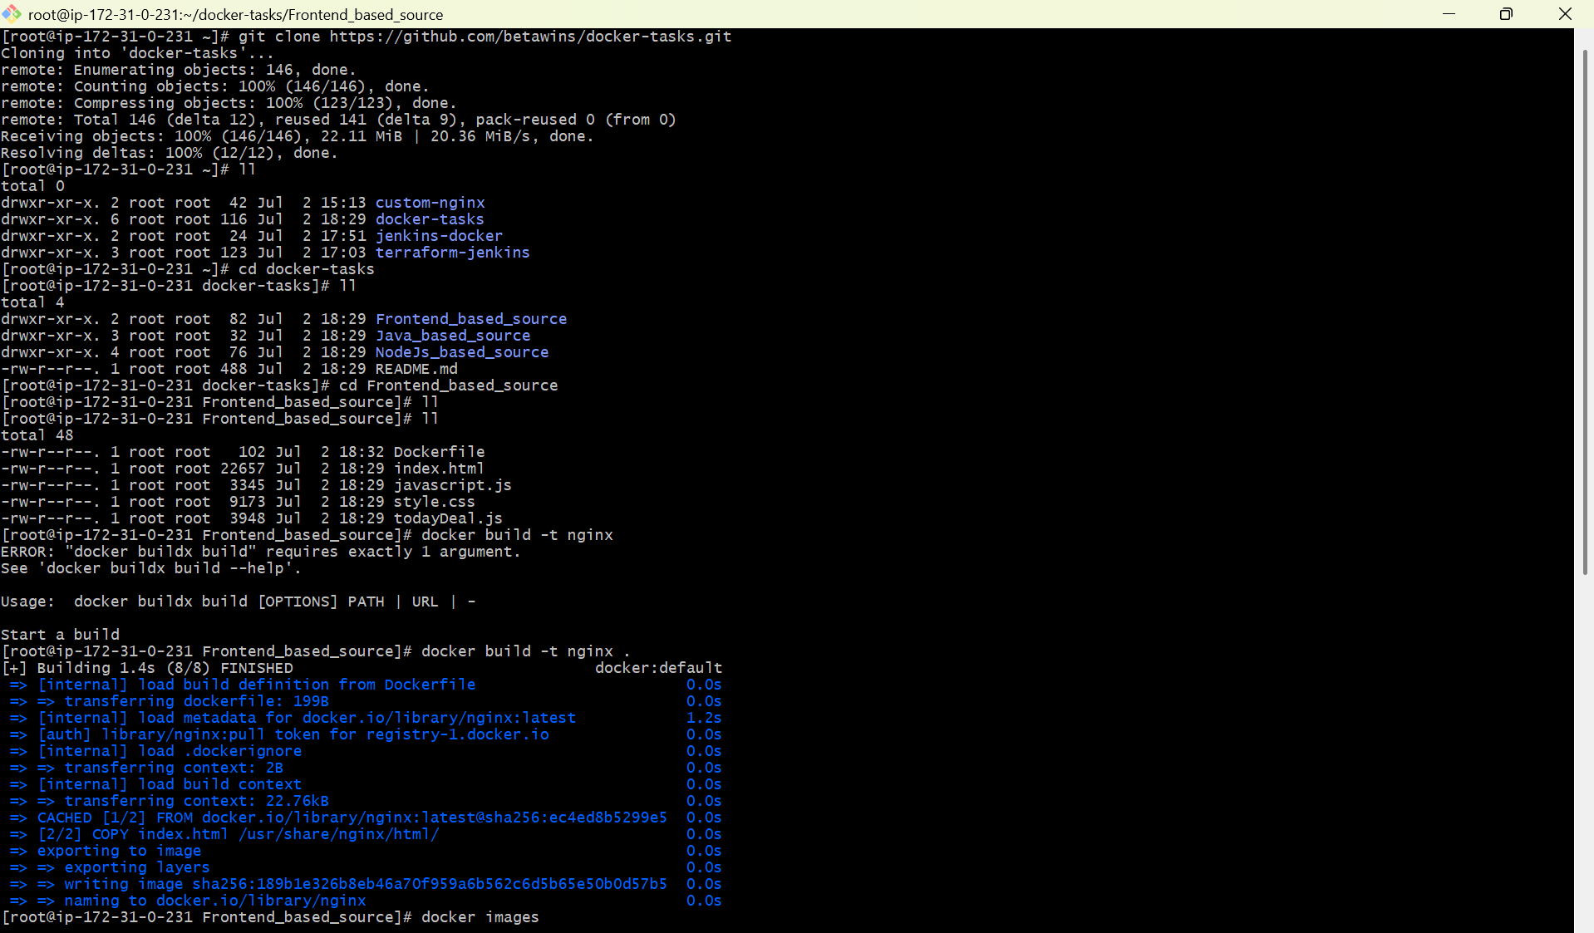

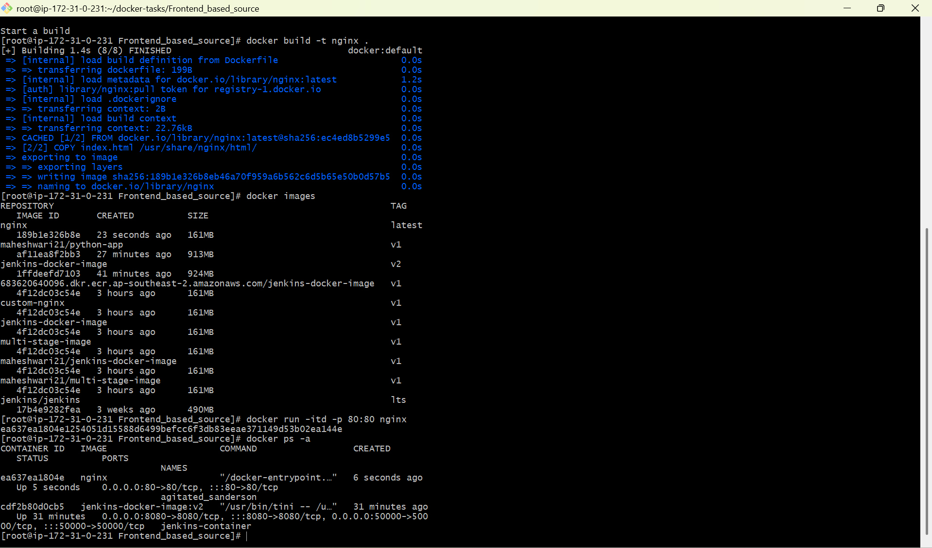

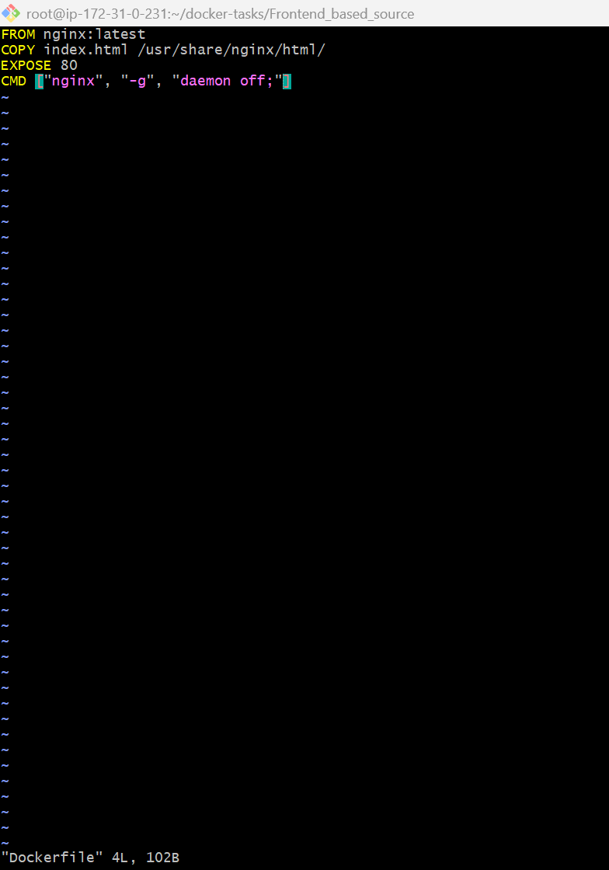

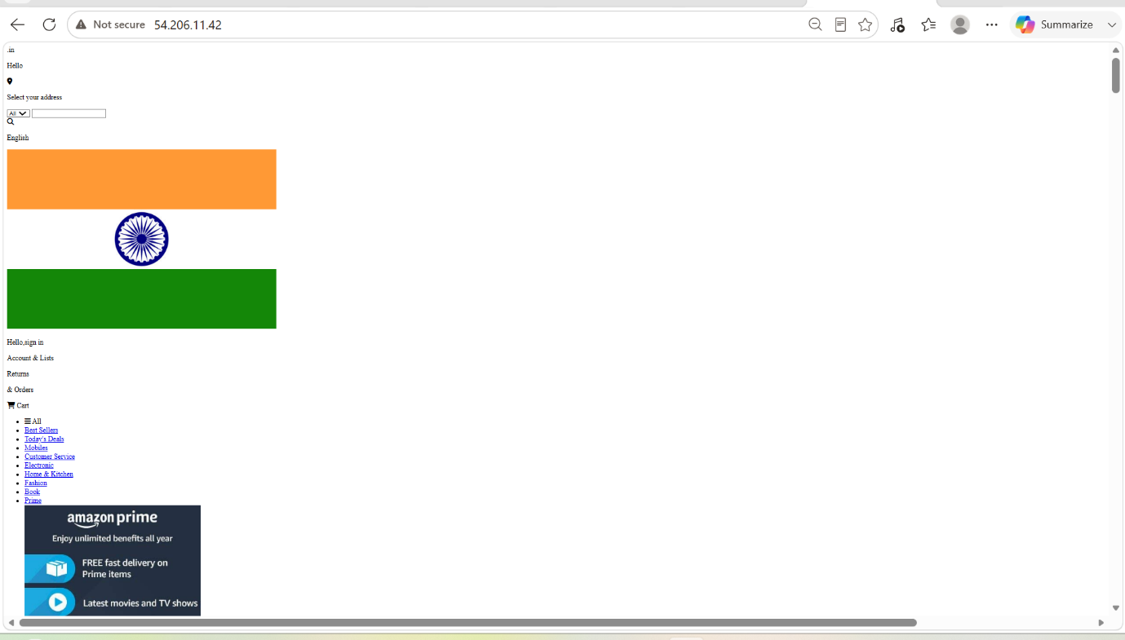

2. From theJava-based source code, write a Dockerfile, build, run, and push the image to the Docker registry.

- After cloning the repo from the central repo.
- Get into that repo and the java-based-source.
- Ther we have to create a new Dockerfile and build a new image from that docker file.
- After building the image we have to run the image in a new container.
- Then we have to push image to the docker hub registry by changing the imagename with the docker hub repo name because docker hub will accept the image name as a repo name only.
- Then after changing the name, we have to push to the docker hub registry -> docker push maheshwari21/java-image.
- Then we can access the app in the browser.

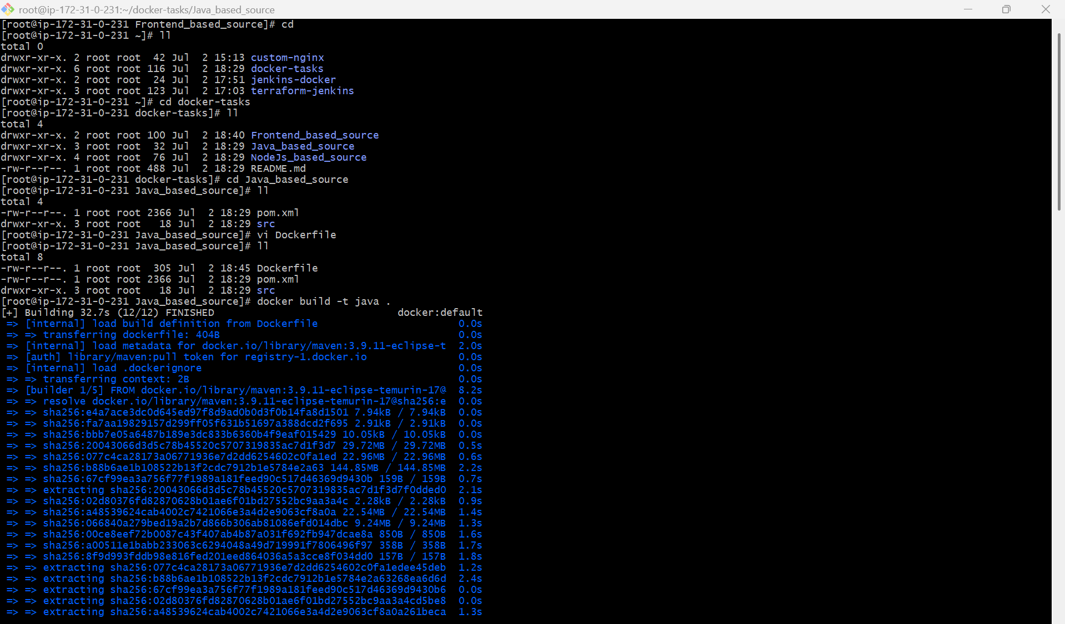

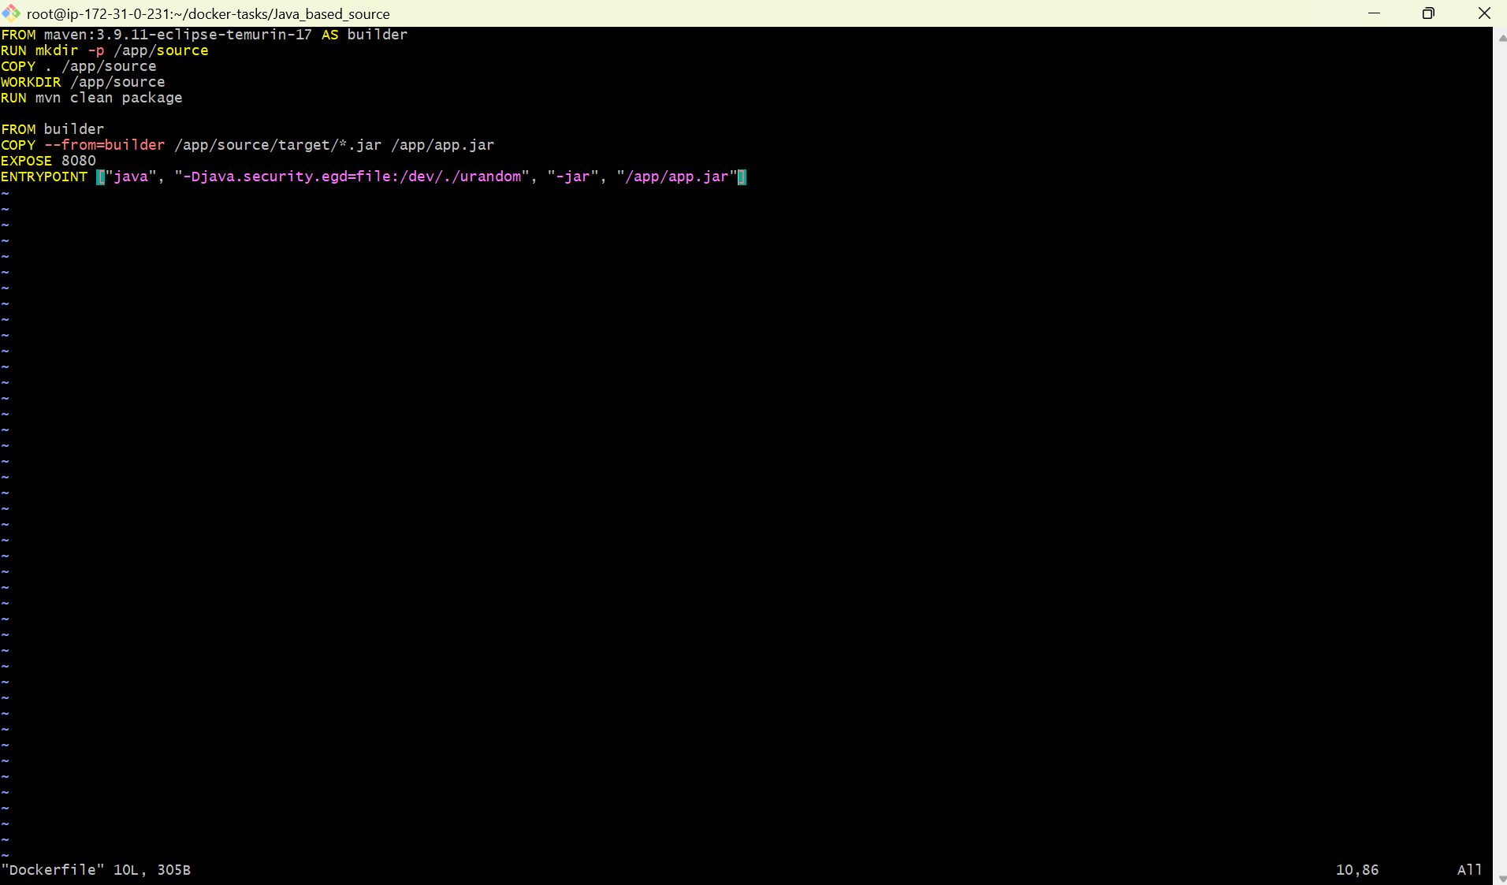

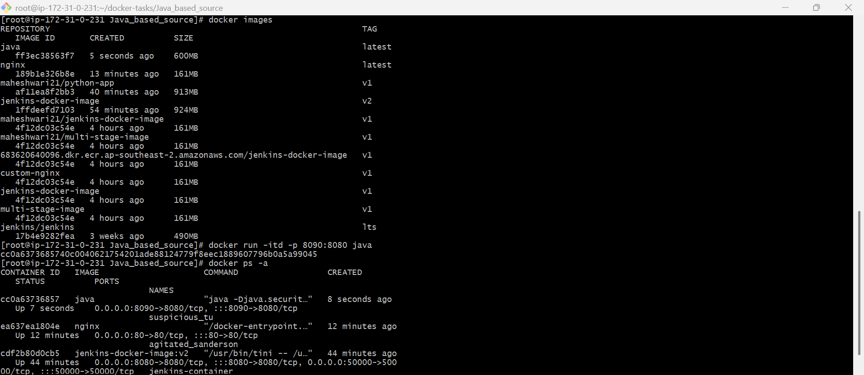

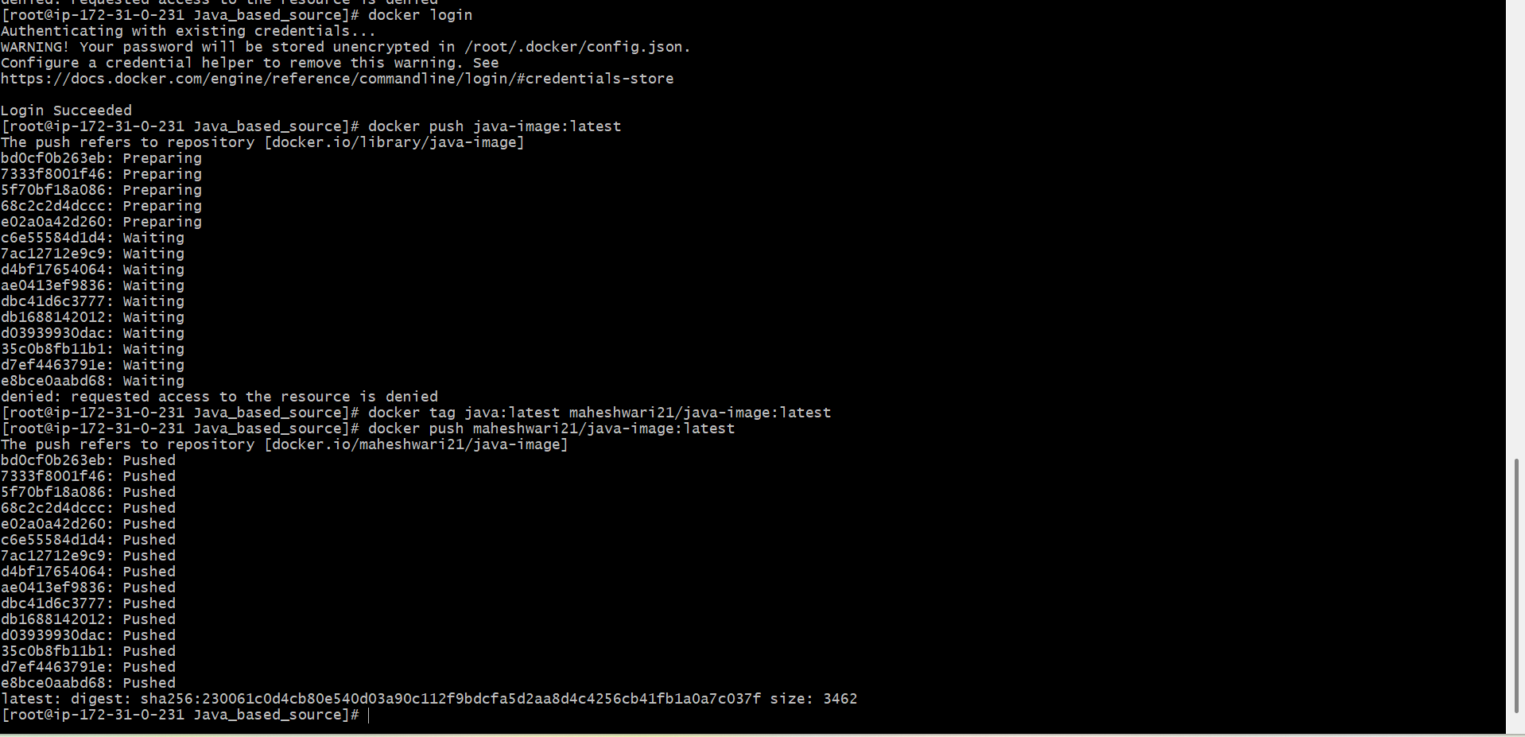

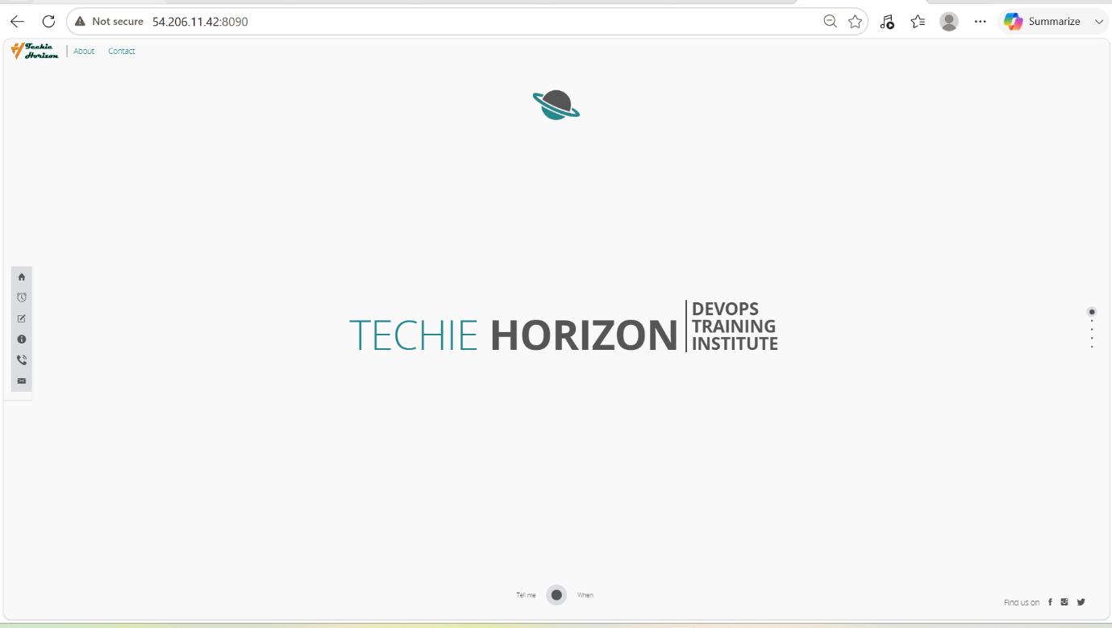

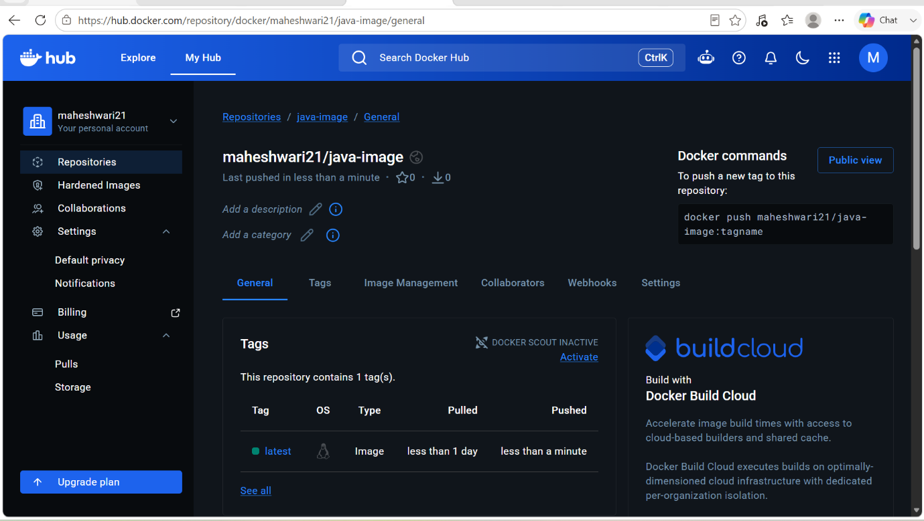

3. From theNode.js-based source code, write a Dockerfile, build with tagv1, run, and push it to the Docker registry.

- Create a new Dockerfile in the NodeJs_based_source.
- And build the image from the Dockerfile -> docker build -t node18 .
- Then we have to run the image in a new container -> docker run -itd -p 9000:3000 <imagename>
- Then we have to change image name into the repo name with the docker hub username like docker tag <oldimagename>:<tag> <dockerhubusername>/<reponame>:<tag>
- Then push the image to the docker hub -> docker push <dockerhubusername>/<imagename>:<tag>
- Then we can browse the app in the browser by the publicIp

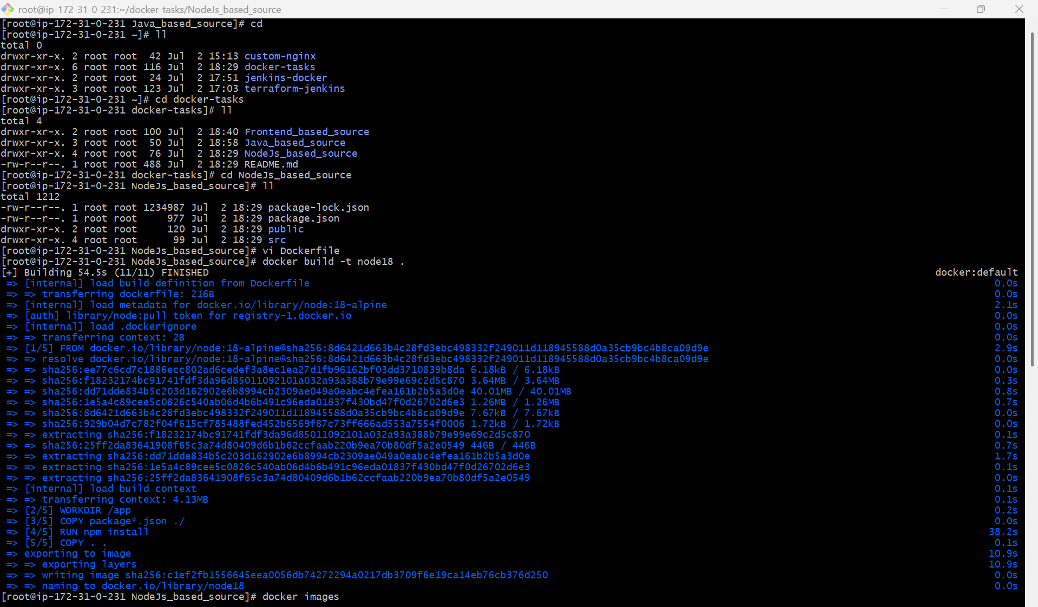

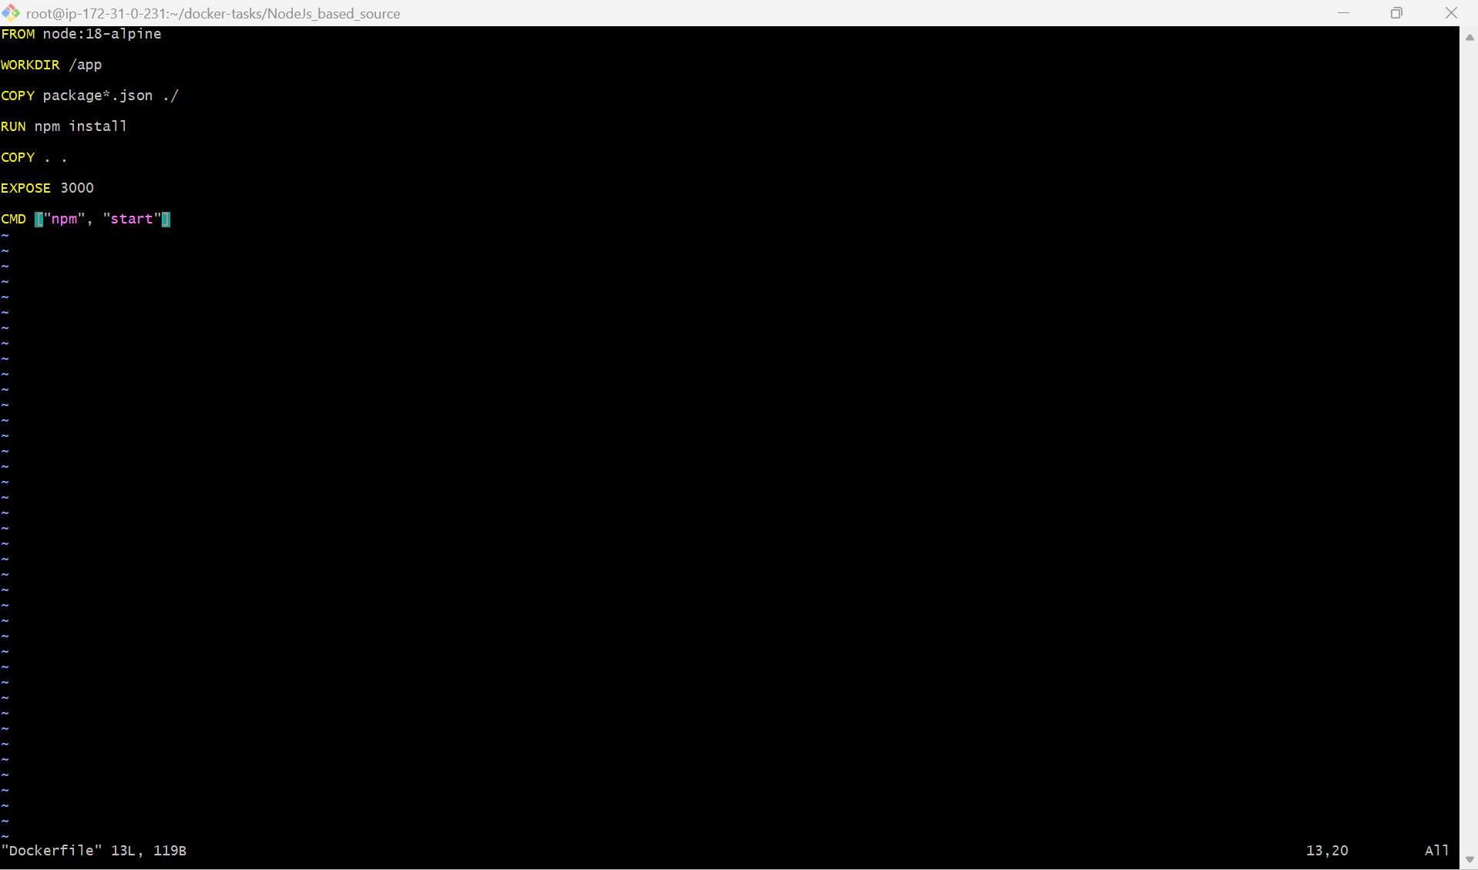

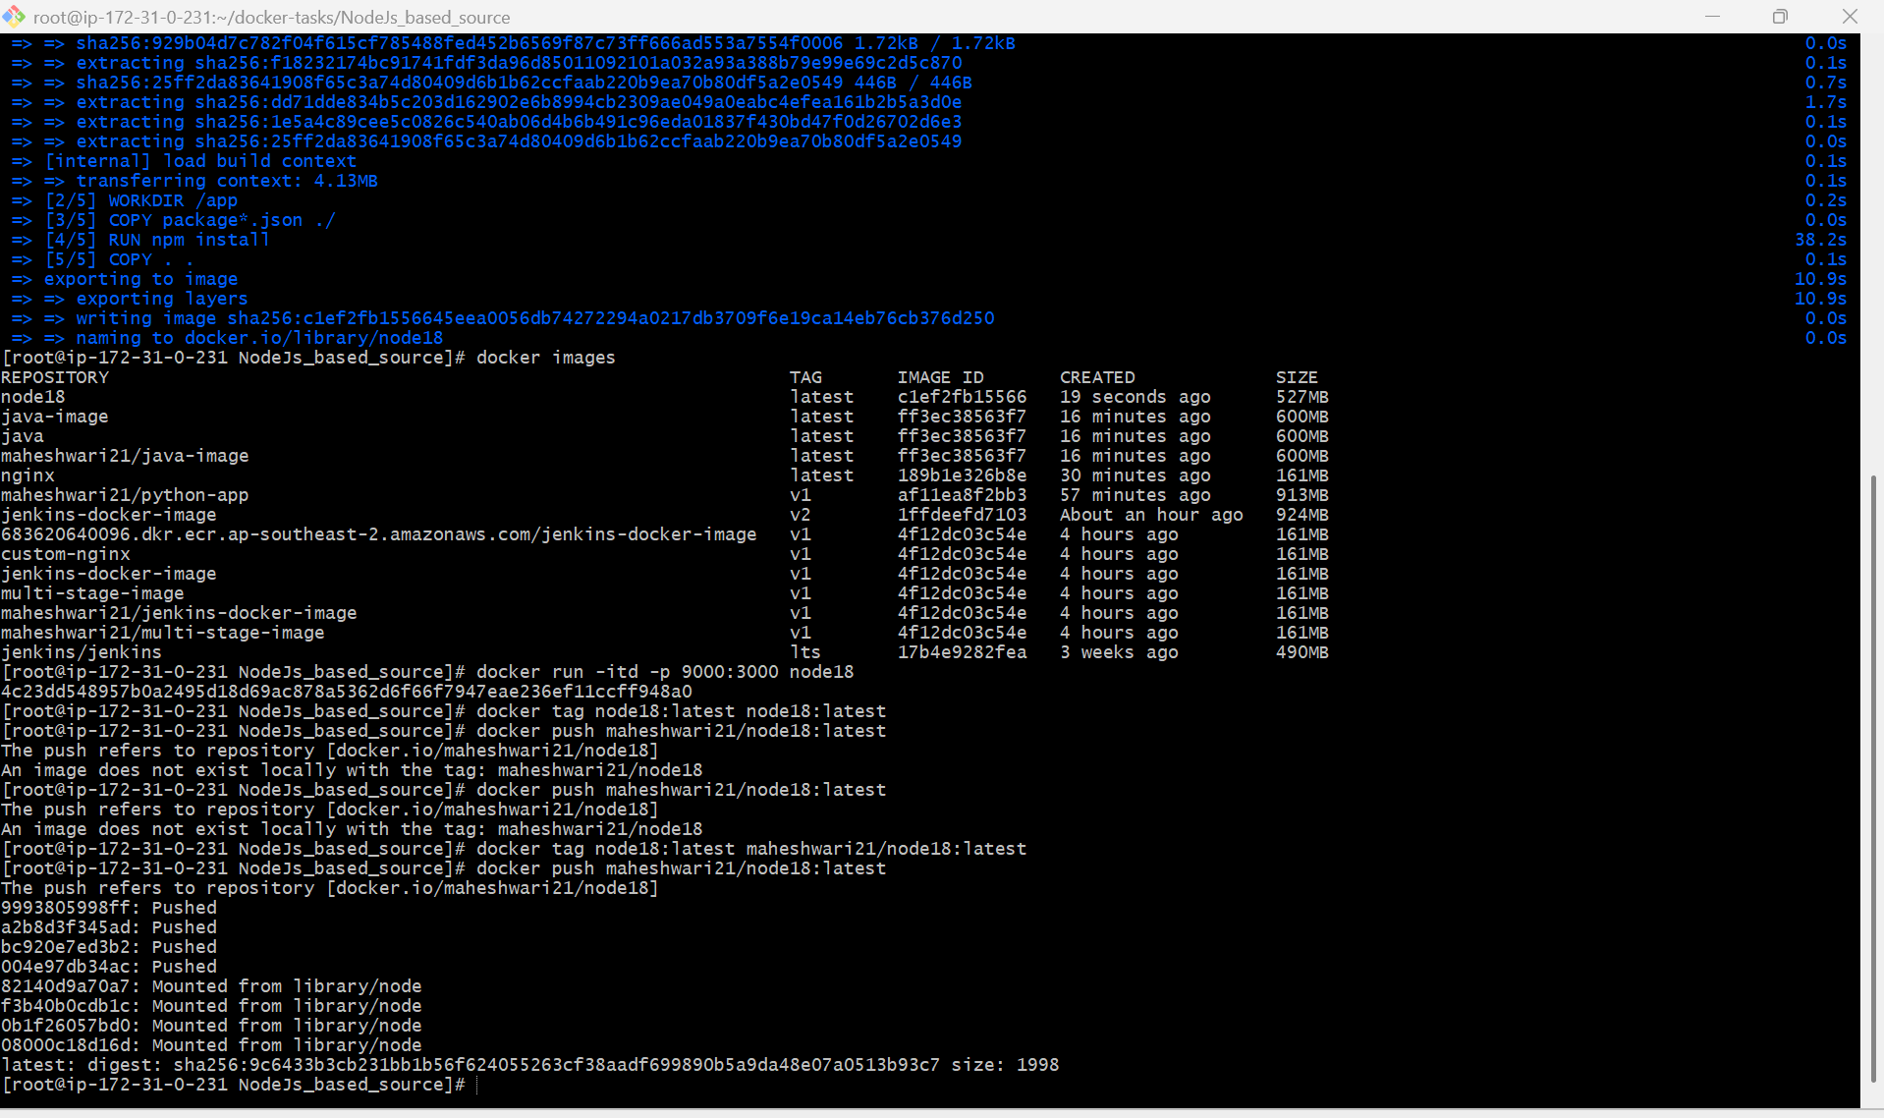

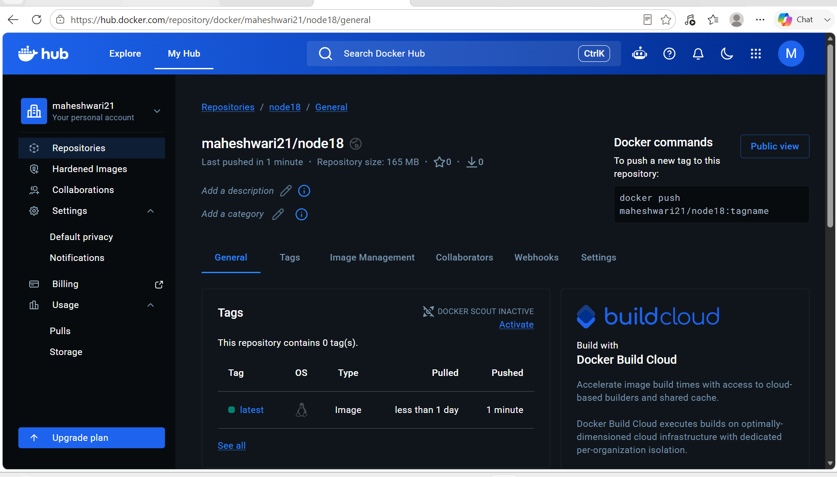



4. Write a docker-compose file to set up WordPress with a MySQL database.

- Download the docker-compose package using curl with link ->
sudo curl -L https://github.com/docker/compose/releases/download/1.21.0/docker-compose-`uname -s`-`uname -m` | sudo tee /usr/local/bin/docker-compose > /dev/null
- After that change the permissions to that file -> sudo chmod +x /usr/local/bin/docker-compose
- Create a symbolic link -> ln -s /usr/local/bin/docker-compose /usr/bin/docker-compose
- Verify the docker-compose installed or not -> docker-compose –version
- Then create a sample docker-compose.yml file for application.

version: '3'
services:
db:
image: mysql:5.7
volumes:
- db_data:/var/lib/mysql
restart: always
environment:
- MYSQL_ROOT_PASSWORD=somewordpress
- MYSQL_DATABASE=wordpress
- MYSQL_USER=wordpress
- MYSQL_PASSWORD=wordpress
wordpress:
depends_on:
- db
image: wordpress:latest
ports:
- "8000:80"
restart: always
environment:
- WORDPRESS_DB_HOST=db:3306
- WORDPRESS_DB_USER=wordpress
- WORDPRESS_DB_PASSWORD=wordpress
- WORDPRESS_DB_NAME=wordpress
volumes:
db_data: { }

- Then run the docker-compose.yml file with the command -> docker-compose up -d
- Then check for the containers -> docker-compose ps

